**Daily Learning**

**Azure Data Factory:**

1. Delete Duplicates rows from tables

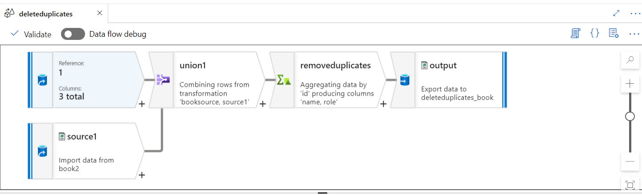

1. Process Fixed Length text files

1. Handle Error Rows

1. Running total in a column

1. SCD 1

1. Add column During Copy

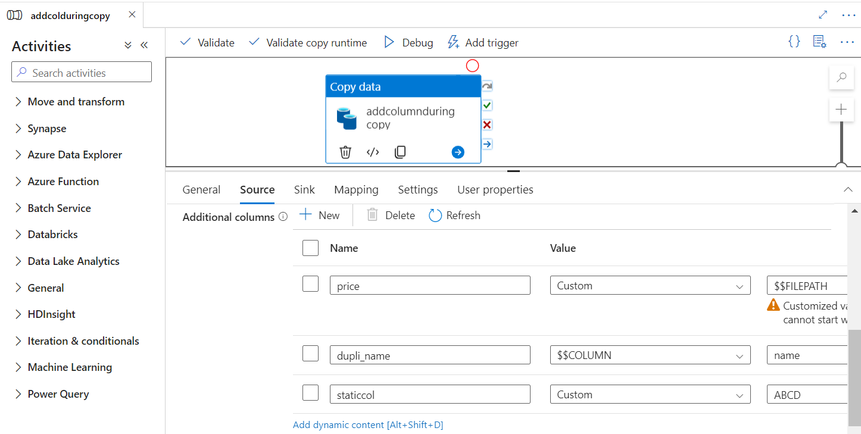

1. Array to string (email column to make a single string with all the emails)

1. Passing Parameters to databricks notebook from ADF

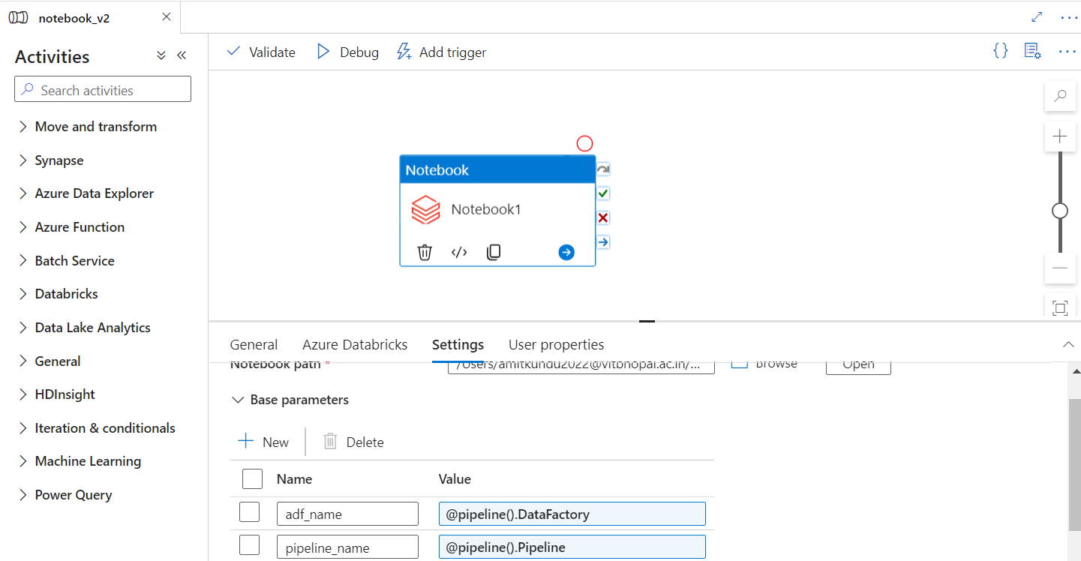

1. Incrementally copy new file

